Required Components
1.   | 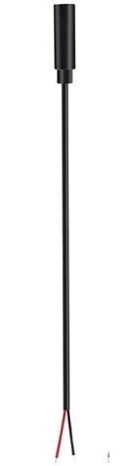  2. | BOM  - Just Play – Sing-Along Elmo  - 3.5 mm Female Mono Cable  - Cable tie (small – around 15 cm is good)  Refer to the Tool and Component List for purchasing details.
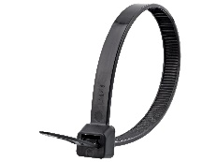

Required Tools
- Phillips screwdriver
- Drill with 1/8” drill bit
- Flush cutters
- Wire strippers
- Soldering iron and solder

Required Personal Protective Equipment (PPE)
- Safety glasses

Assembly Instructions
- Carefully remove the toy from its packaging without damaging it (we will be repackaging the toy after adapting).  Turn over the Elmo and open the Velcro strip along the back.  Pull out the plastic box out of the compartment on the back of the Elmo. | 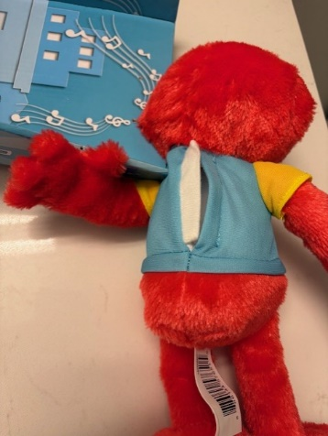
- Unscrew the back of the plastic box and remove the batteries.  *Note: keep screws, and keep track of where they came from | 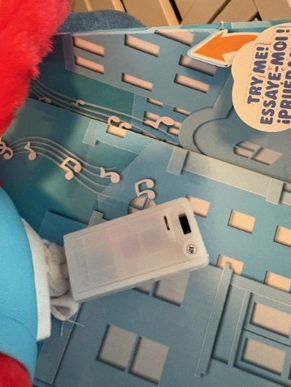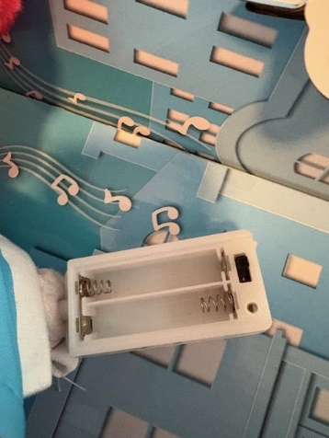
- Unscrew the 4 screws on the front of the plastic box.  Carefully lift the top of the box up and maneuver it over to the side to expose the board.  *Note: Be careful not to pull on any of the wire connections. | 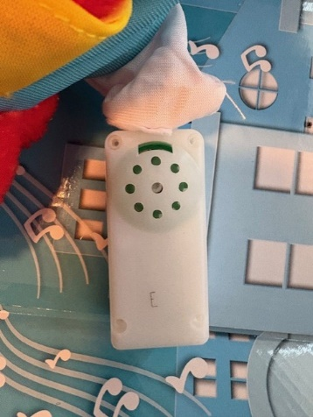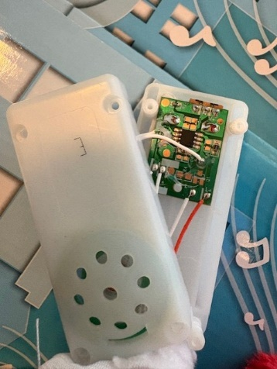
- Drill a hole in the location shown using a drill with a 1/8” drill bit. | 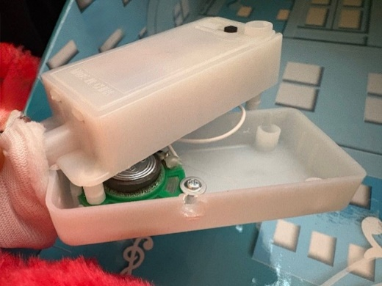  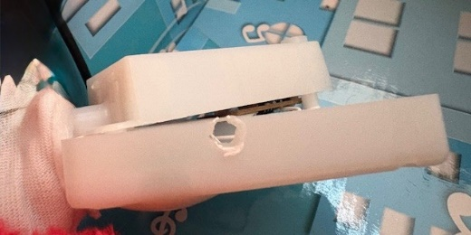
- Use wire strippers to strip approximately 2 cm off the outer wire casing, revealing two internal wires.  *Note: If your mono cables come ready to solder, skip steps 3-5. | 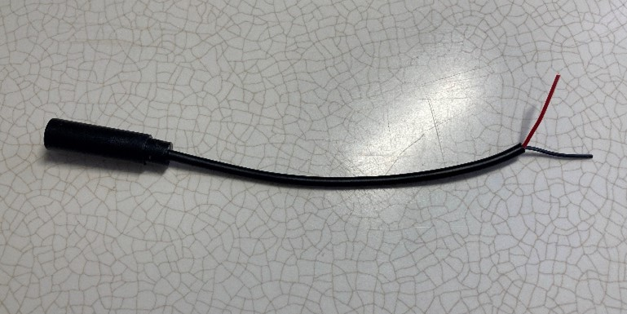
- If there are 2 internal wires, strip approximately 0.5 cm off each wire. | 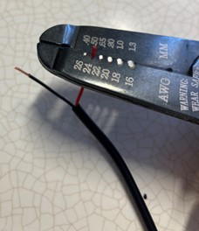
- If there are three internal wires (red, black, and exposed), strip off 0.5 cm of the red insulation and twist the red wire and exposed wire together. Strip 0.5 cm from the black wire. | 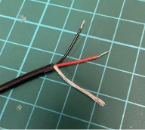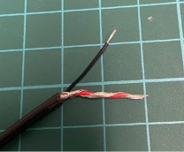
- Melt a small amount of solder over the exposed ends of the wire. | 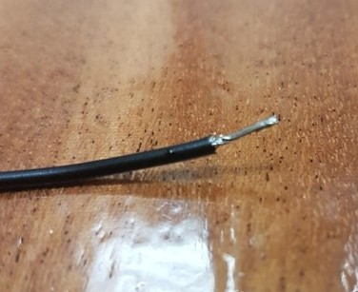
- Thread the cable through the drilled hole. | 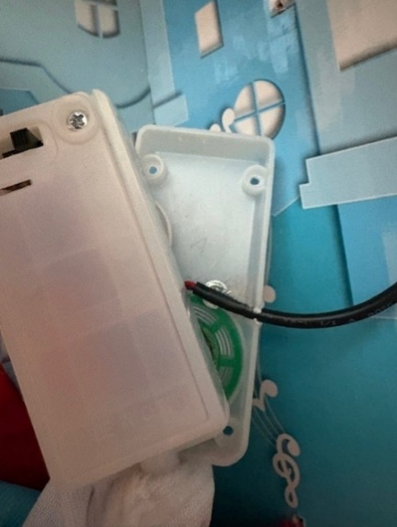
- Solder the two wires in the mono cable to the two soldered joints as shown in the picture. | 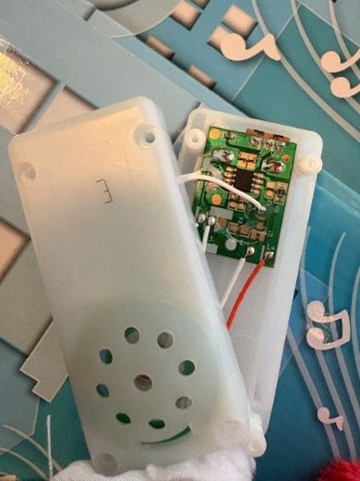  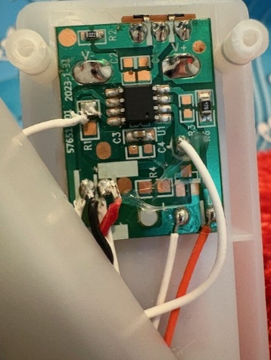
- It is now time to test the toy. Insert batteries into the battery compartment and an assistive switch into the mono jack. The toy will activate when the assistive switch is pressed and when the original button is pressed.  Notes:  - If the toy does not turn on, please check the soldered connections.  - If the toy continuously repeats the song when the switch is released, the connection is shorted. Check for areas of touching solder and separate using a soldering iron. | 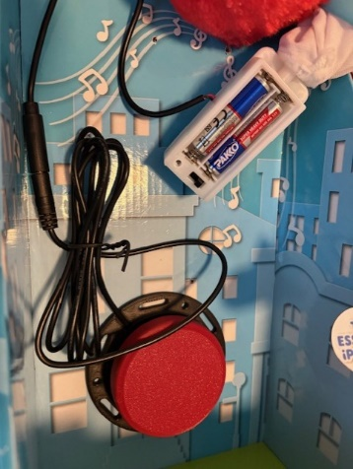
- Attach a cable tie to the cable, on the inside of the plastic box – as close as possible to where it enters.  Tighten the cable tie as much as you can, then cut the excess portion with flush cutters.  This cable tie will serve as strain relief, so that if the cable is pulled it won’t break the solder connections. | 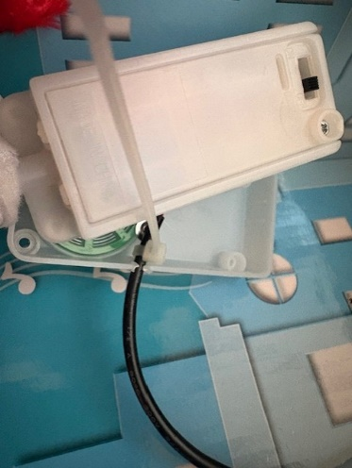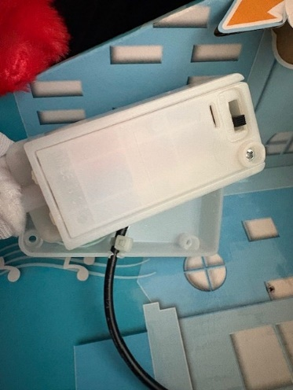
- Carefully lift and slide the top of the plastic box over the bottom. Make sure to reassemble the toy using the screws set aside earlier. | 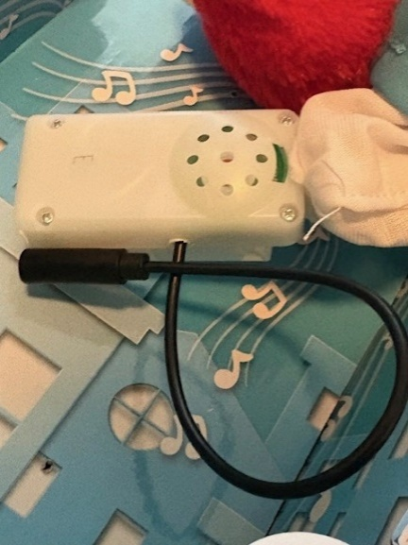
- Put the plastic box back inside compartment in the back of the toy leaving the cable sticking out.  Close the back compartment, make sure the cable with the mono jack is sticking out. | 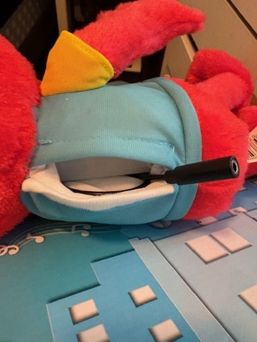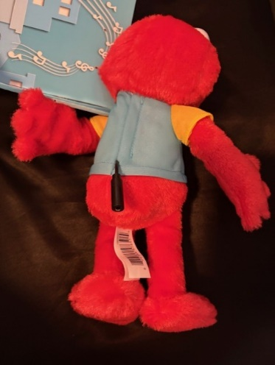
- Test the toy again. If it is still working properly, repackage the toy and the adapted toy is complete! | 